Question 1

1. Create a blank file named "myfile"

2. Open "myfile" in vi editor

3. Write your name, address, email id, phone number and blood group in 5 different lines

4. Build one single expression to see the line with your name and blood group in myfile

Answer:- 1)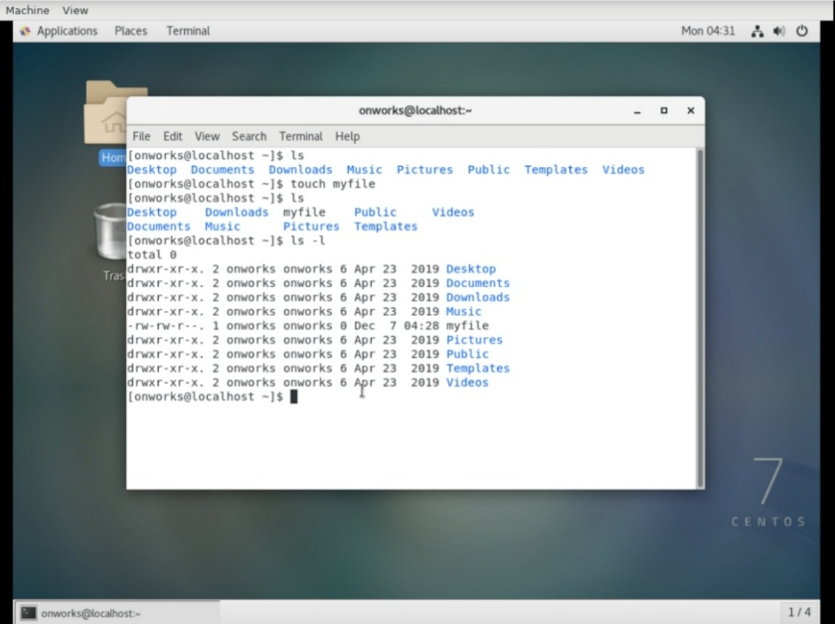

2)

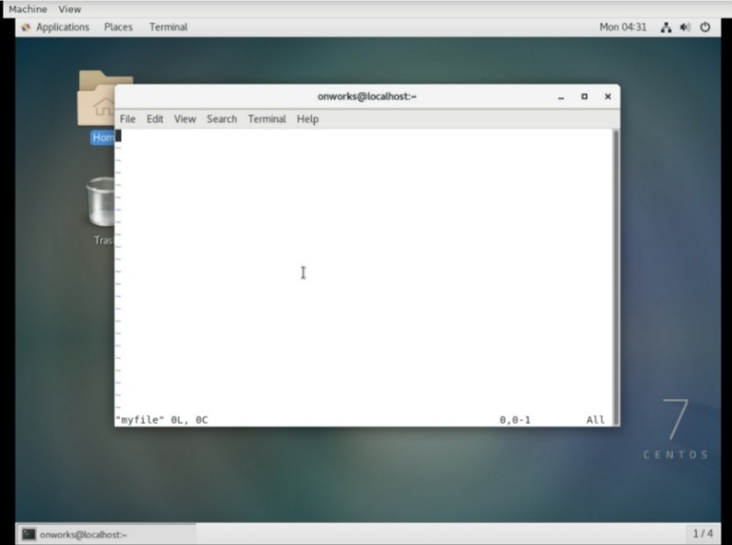

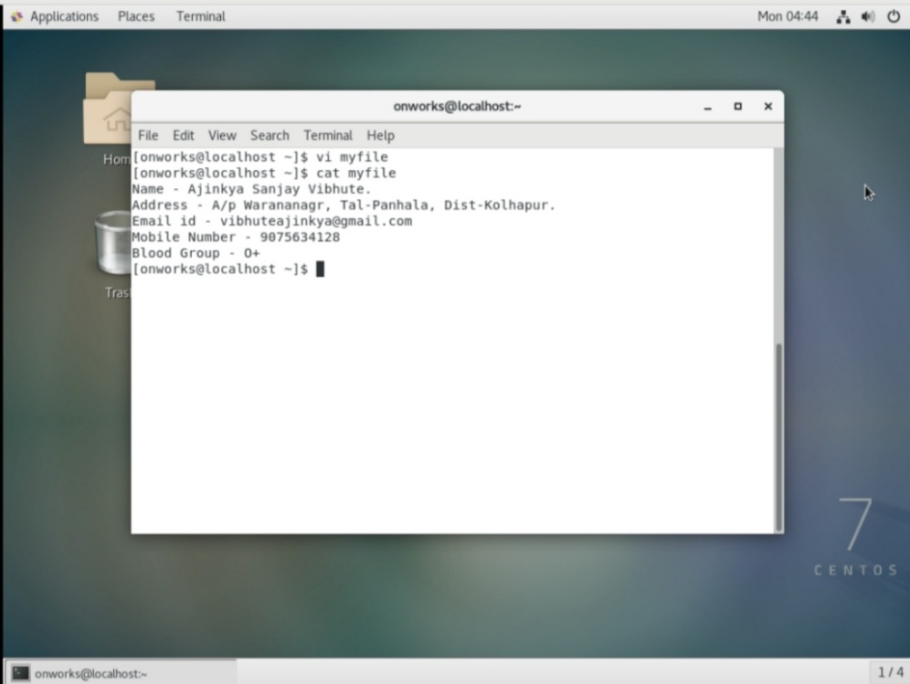3)

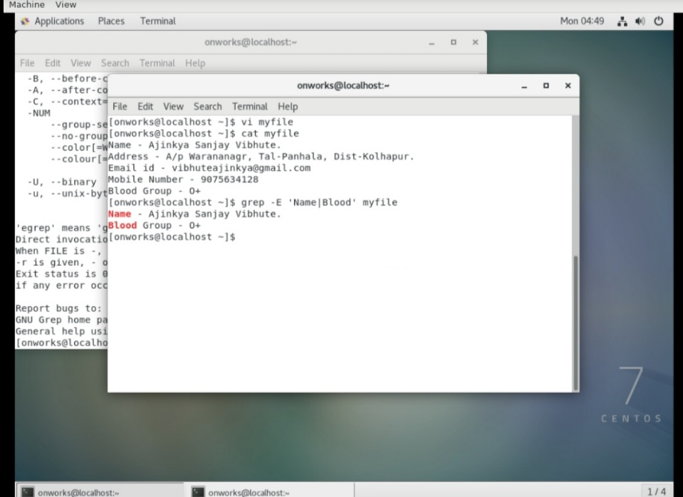4)